Clime

and

Meteorogical Data

Comparison

**Ciudad Real – Málaga Airport**

**Step 1**: Go to AEAT website – Open Data – RSP Plan Catalog

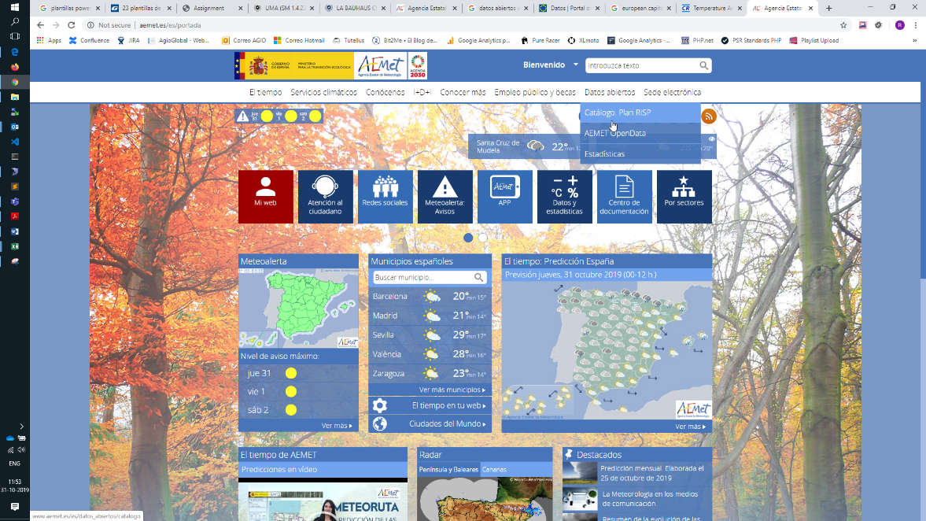

**Step 2**: Select data source

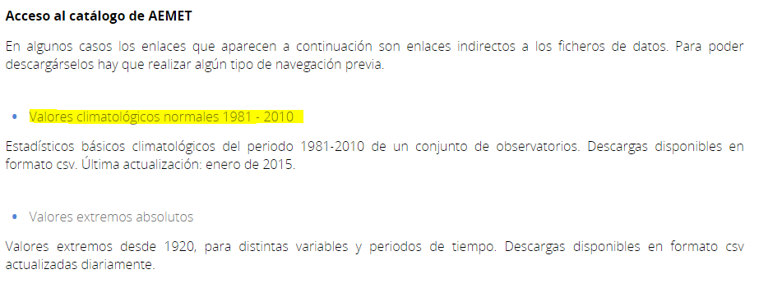

**Step 3**: Select cities and download data for our comparison.

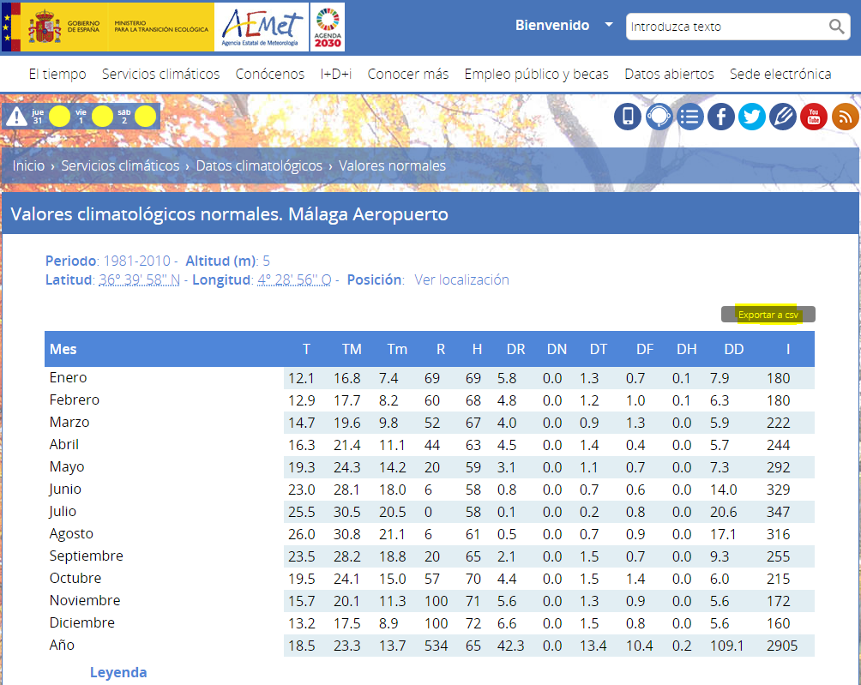

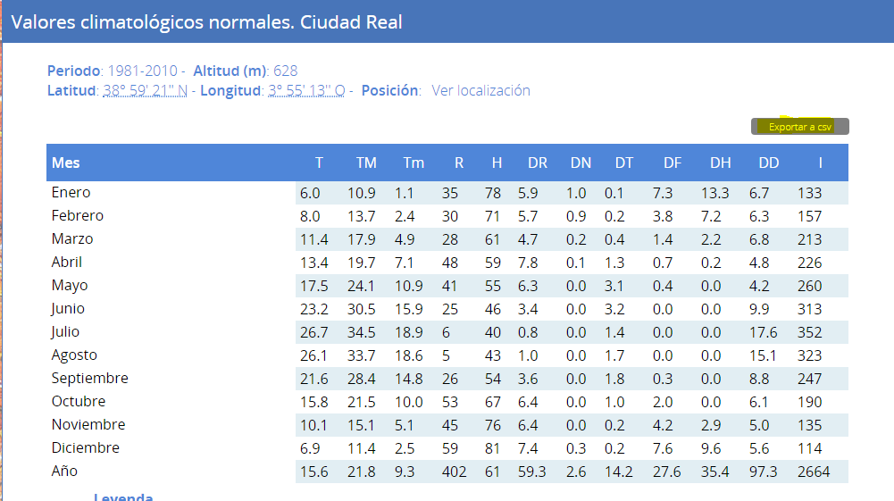

**Step 4**: Import data in Excel program. Format them and compare by related columns.

